**Assignment 1:** Please create circuit with Piezo alarm,PIR sensor,tmp sensor with below functionalities:  
1.Alarm should sound in one manner if temp is above 60 C  
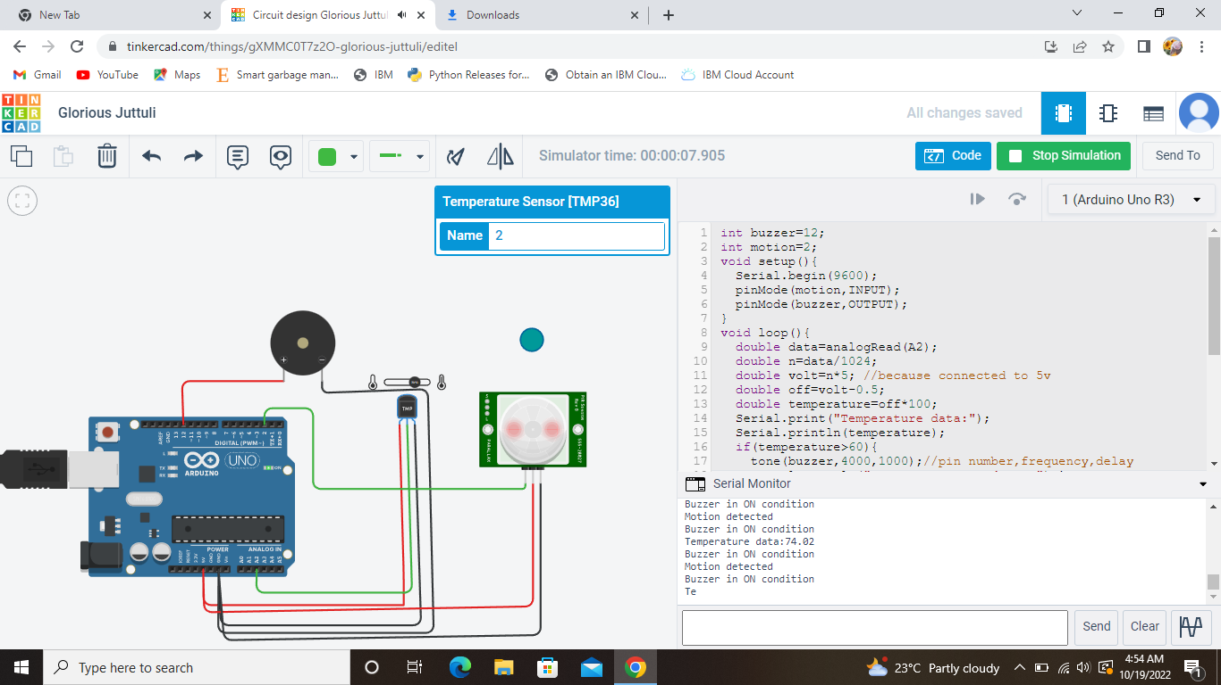2.Alarm should sound with another frequency if motion is detected in PIR sensor

**Code:**

int buzzer=12;

int motion=2;

void setup(){

Serial.begin(9600);

pinMode(motion,INPUT);

pinMode(buzzer,OUTPUT);

}

void loop(){

double data=analogRead(A2);

double n=data/1024;

double volt=n*5; //because connected to 5v

double off=volt-0.5;

double temperature=off*100;

Serial.print("Temperature data:");

Serial.println(temperature);

if(temperature>60){

tone(buzzer,4000,1000);//pin number,frequency,delay

Serial.println("Buzzer in ON condition");}

else{

noTone(buzzer);

Serial.println("Buzzer in OFF condition");

}

int motionData=digitalRead(motion);

if(motionData==1){

Serial.println("Motion detected");

tone(buzzer,8000,1000);

Serial.println("Buzzer in ON condition");

}

else{

Serial.println("No Motion");

Serial.println("Buzzer in OFF condition");}

}